* 1. 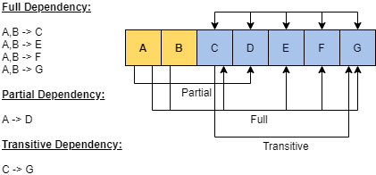
  2. 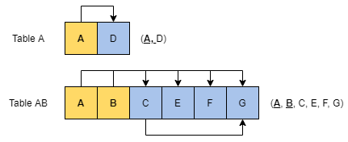
  3. 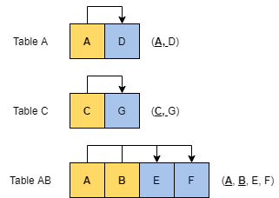
  4. 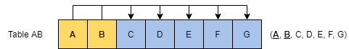
  5. BEGIN TRANSACTION;  
     UPDATE PART SET PART_ONHAND = PART_ONHAND - 1 WHERE PART_NUM = “X”;  
     UPDATE PART SET PART_ONHAND = PART_ONHAND - 2 WHERE PART_NUM = “Y”;  
     UPDATE PART SET PART_ONHAND = PART_ONHAND - 2 WHERE PART_NUM = “Z”;  
     UPDATE PRODUCT SET PROD_ONHAND = PROD_ONHAND + 1 WHERE PROD_NUM = “C3P0”;  
     COMMIT;

|  |  |  |  |  |  |  |  |  |  |
| --- | --- | --- | --- | --- | --- | --- | --- | --- | --- |
| **TRL_ID** | **TRX_NUM** | **PREV_PTR** | **NEXT_PTR** | **OPERATION** | **TABLE** | **ROW_ID** | **ATTRIBUTE** | **BEFORE_VALUE** | **AFTER_VALUE** |
| 1 | 1 | NULL | 2 | START | BEGIN TRANSACTION | | | | |
| 2 | 1 | 1 | 3 | UPDATE | PART | X | PART_ONHAND | 98 | 97 |
| 3 | 1 | 2 | 4 | UPDATE | PART | Y | PART_ONHAND | 275 | 273 |
| 4 | 1 | 3 | 5 | UPDATE | PART | Z | PART_ONHAND | 153 | 151 |
| 5 | 1 | 4 | 6 | UPDATE | PRODUCT | C3P0 | PART_ONHAND | 41 | 42 |
| 6 | 1 | 5 | NULL | COMMIT | END TRANSACTION | | | | |